NIST CYBERSECURITY FRAMEWORK (CSF) 2.0
Cybersecurity Posture Assessment Report
Northstar HealthTech Pvt. Ltd.
Assessment basis: simulated organization-interview scenario and assessment working papers
Assessment Framework | NIST Cybersecurity Framework (CSF) 2.0
Assessment Type | Cybersecurity posture / outcome-based assessment
Organization | Northstar HealthTech Pvt. Ltd.
Assessment Date | 2026
Prepared By | External GRC / NIST CSF Assessor

1. Executive Summary
Purpose. Northstar HealthTech requested a NIST CSF 2.0 assessment to understand its current cybersecurity posture, identify material gaps against a defined target state, and support practical prioritization of improvement actions.
Overall conclusion. The assessment working papers show a mixed cybersecurity posture. Across 106 assessed outcomes, the current profile contains 47 outcomes at maturity level 3 (Repeatable), 24 at level 2 (Risk Informed), 31 at level 1 (Partial), and 4 recorded as TBD where the available scenario information does not support a defensible maturity conclusion. The average current maturity across the 102 numerically scored outcomes is 2.16 on a 1–4 scale, against the project target of level 3.
Key message for management. The principal improvement opportunity is not the absence of cybersecurity activity across the organization; rather, it is the consistency, completeness, traceability and enterprise-wide repeatability of existing practices.

Key observations
- Governance and asset/service visibility require significant strengthening, including more complete understanding of assets, dependencies, requirements and risk context.
- Access management is not consistently applied across applications; the scenario specifically identifies legacy administrative applications without MFA and uneven access-review practices.
- Monitoring coverage is incomplete across production components, limiting visibility of security events across the full service environment.
- Data classification exists as a policy expectation but is not consistently applied across repositories.
- Incident response and recovery capabilities exist, but exercises, follow-up actions, restoration testing and recovery sequencing are not consistently mature.
- Third-party security practices are established for higher-risk suppliers, but assessment depth/frequency and security-focused exit activities vary.
- The assessment identifies 31 Major and 24 Minor gaps based on the existing gap scoring; no Critical gap is currently recorded in the submitted working paper.

2. Assessment Overview

2.1 Organization Context
- India-based healthcare technology company with approximately 320 employees.
- B2B SaaS provider serving hospitals and diagnostic centres, with customers in India, Singapore and the UAE.
- Hybrid workforce with a Bengaluru corporate office and production hosted primarily in a public cloud environment.
- Core services include appointment/clinic management, patient communication, customer administration, public/partner APIs, billing/subscription management and customer support.
- Security is supported by a small internal security team, IT Operations, Engineering and an external managed security provider.

2.2 Assessment Scope
- Business services, production SaaS platform, web applications, APIs, identity platform, databases, backups, cloud infrastructure and supporting technology.
- Relevant internal functions including Security, IT Operations, Engineering, HR, Procurement, Legal & Compliance, CISO and senior management.
- Relevant third parties, suppliers and MSSP for the services they provide.
- Patient-related information, customer administrative/billing information, HR information, source code, deployment credentials and production backups.
- All six NIST CSF 2.0 Functions were treated as in scope for the simulation; the project assumption was to assess all 106 outcomes as applicable.

2.3 Boundaries and Limitations
- Physical security was defined as out of scope.
- Penetration testing, vulnerability scanning and application security testing execution were outside the assessment; existing results could be used as supporting evidence.
- Third parties/MSSP were considered only for the services they provide, not for an overall assessment of their enterprise security posture.
- This is a simulated assessment. Conclusions are based only on the supplied Northstar scenario and completed assessment working papers.
- Where the scenario did not provide sufficient information for a defensible conclusion, the working papers use TBD rather than inventing evidence.

3. Assessment Methodology
The assessment used an outcome-based approach combining organization understanding, scope definition, evidence requirements, evidence review, current profiling, target profiling, gap analysis, risk assessment and prioritization, followed by action planning.

3.1 Maturity Scale
Score | Level | Interpretation
1 | Partial | No/minimal implementation; reactive in nature.
2 | Risk Informed | Implementation exists but may be undocumented, inconsistent, unreviewed or not fully effective.
3 | Repeatable | Formally documented, communicated and consistently implemented.
4 | Adaptive | Adapted and proactive.

3.2 Gap and Risk Methodology
- Gap Score = Target Maturity Score – Current Maturity Score.
- Gap Severity: 0 = No Gap; 1 = Minor; 2 = Major; 3 = Critical.
- Risk Score = Likelihood × Impact.
- Impact Score = MAX(Confidentiality, Integrity, Availability).
- Risk prioritization uses the agreed risk score as the primary factor, with gap severity, business criticality, obligations, dependencies, resource constraints and management priorities considered in final prioritization.
- For this simulation, the Target Profile is fixed at maturity level 3 for all 106 outcomes.

4. Current Cybersecurity Profile
The table below summarizes the current maturity profile captured in the assessment working paper. The figures are derived directly from the submitted Action Plan workbook; no current scores have been changed for this report.
CSF Function | Outcomes | Avg. Current | Level 1 | Level 2 | Level 3
Govern | 31 | 1.97 | 10 | 10 | 9
Identify | 21 | 2.19 | 6 | 5 | 10
Protect | 22 | 2.05 | 9 | 1 | 10
Detect | 11 | 2.64 | 1 | 2 | 8
Respond | 13 | 2.15 | 4 | 3 | 6
Recover | 8 | 2.38 | 1 | 3 | 4
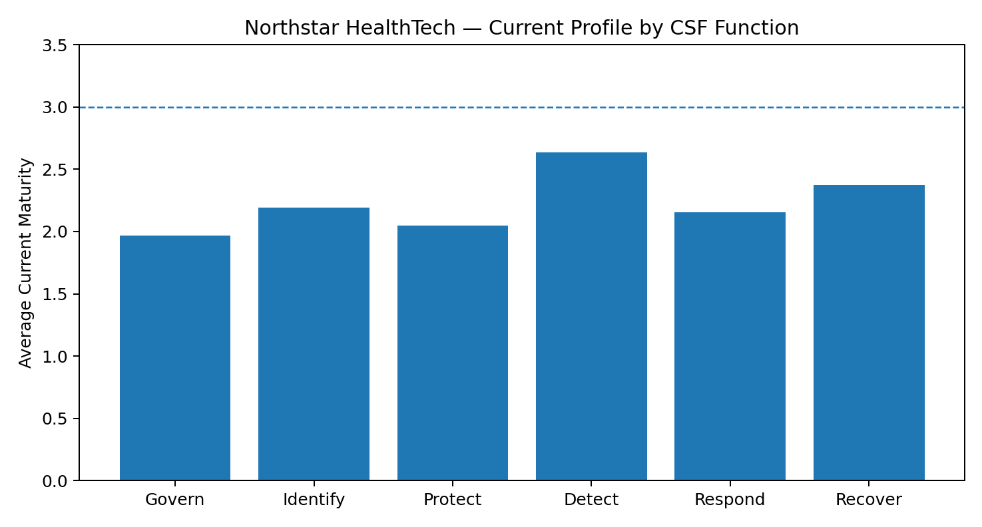
Interpretation. Detect has the strongest average current profile (2.64), while Govern has the lowest (1.97). Govern, Protect and Respond contain the greatest concentration of lower-maturity outcomes. The target state for all outcomes is level 3, so level 1 and level 2 outcomes represent the principal improvement population.

5. Gap Analysis
The working paper records 46 outcomes with no gap, 24 Minor gaps, 31 Major gaps and 4 outcomes marked TBD due to insufficient information. No Critical gap is currently recorded.
Gap Severity | Count | Meaning
No Gap | 46 | Current maturity meets the target of 3.
Minor | 24 | One-level improvement required.
Major | 31 | Two-level improvement required.
Critical | 0 | Three-level improvement required.
TBD | 4 | Insufficient information for a defensible current score.

5.1 Principal Improvement Themes
Governance, risk and requirements visibility: Strengthen enterprise visibility of cybersecurity risk, legal/regulatory/contractual requirements and management decision-making.
Asset, service and dependency visibility: Establish a more complete view of technology assets, business-service dependencies and critical supporting components.
Identity and access management: Improve consistency of access reviews and address legacy administrative access weaknesses, including the identified lack of MFA.
Data protection and classification: Improve consistent application of data classification and visibility of protection measures across repositories.
Monitoring and detection coverage: Extend monitoring visibility across production services and components so coverage is understood and gaps are managed.
Incident response and recovery: Strengthen exercise frequency, follow-up tracking, restoration testing and recovery sequencing for critical services.
Third-party and supplier security: Improve consistency of supplier security reviews, dependency visibility and security-focused supplier exit practices.

6. Risk Assessment & Prioritization
Status of risk scoring. The submitted Action Plan workbook contains the risk-assessment fields, but the Likelihood, CIA Impact, Risk Score and Priority fields are not yet populated for the 106 outcomes (106 currently contain a risk score). Accordingly, this report does not invent or infer risk scores.
For a production assessment, detailed likelihood and impact assessment should be performed for material/significant gaps where risk prioritization is required. The assessment methodology defines Likelihood on a 1–5 scale and Impact using the maximum of Confidentiality, Integrity and Availability.

Risk prioritization principles
- Do not derive Likelihood from Gap Score alone.
- Assess Likelihood using exposure, credible threat path, control weaknesses, compensating controls and relevant threat activity.
- Assess Confidentiality, Integrity and Availability according to the nature of the affected information/service and potential business consequences.
- Use the maximum CIA score as the Impact Score.
- Use Risk Score as the primary prioritization factor, then consider business criticality, obligations, dependencies, resource constraints and management priorities.

7. Improvement Action Plan
The Action Plan workbook is designed to convert identified gaps into management-owned treatment actions. The final plan should be completed for the material/prioritized gaps rather than treating every outcome as an equal remediation project.
Action Planning Element | Purpose | Example Evidence | Owner | Closure
Recommended Action | Specific remediation/improvement activity. | Updated procedure, configuration or implementation record. | Risk/action owner | Action completed.
Treatment Option | How the risk will be handled. | Approved treatment decision. | Risk owner / management | Treatment decision approved.
Risk Owner | Accountability for the risk. | Named accountable function/person. | Business/risk owner | Ownership confirmed.
Target Timeline | Expected remediation period. | Approved target date/roadmap. | Action owner | Milestone met.
Expected Outcome | What improved state should look like. | Outcome evidence. | Action owner | Outcome demonstrated.
Closure Criteria | What evidence proves closure. | Configuration, records, testing or review evidence. | Assessor / control owner | Closure validated.

8. Recommended Improvement Roadmap
The following roadmap is a management-level sequencing recommendation based on the themes and gaps already documented. It is intentionally directional; detailed dates and owners should come from the completed Action Plan.
Horizon | Focus | Illustrative Outcomes | Management Rationale
Near term | Risk & visibility | Enterprise asset/service/dependency view; requirements traceability; access-review consistency; monitoring coverage mapping. | Improve management visibility and reduce blind spots.
Near term | High-value control weaknesses | Legacy administrative authentication; critical access reviews; key monitoring and recovery gaps. | Address weaknesses with potentially high business/security consequence.
Medium term | Operational consistency | Third-party review consistency; data classification application; incident-response exercise follow-up; recovery testing. | Move from fragmented practices toward repeatable execution.
Longer term | Continuous improvement | Metrics, control effectiveness monitoring, adaptive practices and recurring management review. | Sustain and improve the target Repeatable posture.

9. Conclusion
Northstar has a meaningful cybersecurity foundation across governance, protection, detection, response and recovery, but the assessment indicates that practices are not yet consistently repeatable across the enterprise. The largest opportunity is to improve consistency, visibility and traceability rather than simply introduce isolated new controls.
The assessment should therefore be used as a management improvement baseline. The next management activity is to finalize risk scoring for material gaps, confirm owners and treatment decisions, establish realistic timelines, and validate closure through objective evidence.

Appendix A — Assessment Assumptions
- This is a simulated NIST CSF 2.0 assessment based on the supplied Northstar organization-interview scenario and completed working papers.
- All 106 outcomes were treated as applicable for the simulation as a project-level assumption. Applicability does not mean that an outcome is implemented or effective.
- The Target Profile is fixed at maturity level 3 for all 106 outcomes for this simulation.
- Existing Current Profile scores were retained as supplied; the report does not introduce revised maturity judgments.
- TBD outcomes remain TBD where the supplied information did not support a defensible score.
- Physical security remains outside the defined assessment boundary.

Appendix B — Source Working Papers
- Scenario.docx — Northstar organization interview information and assessment context.
- Assessment Objective & Scope — assessment purpose, scope and boundaries.
- Assessment Plan & Methodology — assessment approach, maturity model and risk methodology.
- 06. Assessment & Profiling.xlsx — current profile, target profile and gap analysis.
- 08. Action Plan(1).xlsx — consolidated gap, risk assessment and action-planning structure.

Appendix C — Management Reporting Note
This report is designed as the management-facing narrative. The detailed outcome-level assessment, evidence requirements, gap analysis, risk calculations and action register remain in the underlying working papers and should be maintained as the auditable assessment record.

